Assignment: 2

Section 1: Multiple Choice
1) Which of the following precautions should be taken before working on computer hardware?
Ans: b) Wear an anti-static wrist strap to prevent damage from electrostatic discharge.
2. What is the purpose of thermal paste during CPU installation?
Ans: c) To improve thermal conductivity between the CPU and the heat sink.
3. Which tool is used to measure the output voltage of a power supply unit (PSU)?
Ans: a) Multimeter
4. Which component is responsible for storing BIOS settings, such as date and time, even when the computer is powered off?
Ans: a) CMOS battery

Section 2: True or false
5. True or False: When installing a new hard drive, it is essential to format it before use.
Ans: true
6. True or False: A POST (Power-On Self-Test) error indicates a problem with the CPU.
Ans: False
7. True or False: It is safe to remove a USB flash drive from a computer without ejecting it first.
Ans: False
Section 3: Short Answer

8. Describe the steps involved in installing a new graphics card in a desktop computer.
Ans: 1. Power off the computer and unplug it.
2. Open the computer case.
3. Locate the PCIe x16 slot on the motherboard.
4. Remove the expansion slot cover on the case.
5. Insert the graphics card firmly into the PCIe slot.
6. Secure the card to the case with screws.
7. Connect any required power cables from the PSU.
8. Close the case, plug in the PC, and install/update graphics drivers.

9. What is RAID, and what are some common RAID configurations?
ANS: RAID (Redundant Array of Independent Disks): A storage system that combines multiple hard drives for performance, redundancy, or both.
Common configurations:
RAID 0: Striping (improves speed, no redundancy).
RAID 1: Mirroring (data copied to two drives, provides redundancy).
RAID 5: Striping with parity (balanced speed + fault tolerance).
RAID 10: Combination of RAID 1 & RAID 0 (speed + redundancy).

Section 4: Practical Application

10. Demonstrate how to replace a CPU fan in a desktop computer.
Ans: 1. Power off and unplug the computer.
2. Open the computer case.
3. Disconnect the CPU fan’s power cable from the motherboard.
4. Unscrew or unclip the old fan/heatsink assembly.
5. Clean off old thermal paste from the CPU surface.
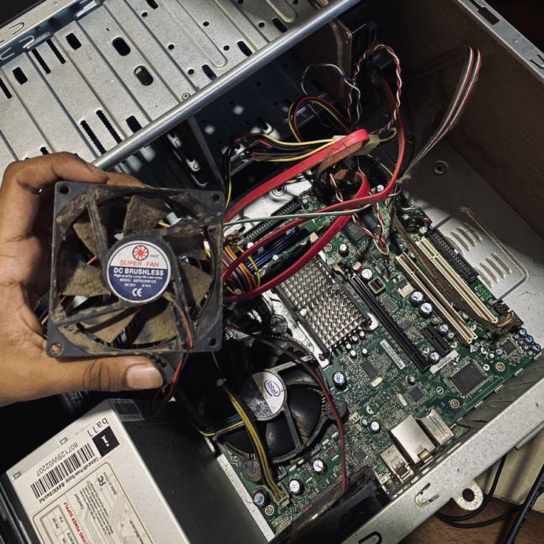
6. Apply a small amount of new thermal paste.
7. Install the new CPU fan/heatsink securely.
8. Reconnect the fan cable to the CPU fan header on the motherboard.
9. Close the case and power on the system.

Section 5: Essay

11. Discuss the importance of regular maintenance for computer hardware and provide examples of maintenance tasks.
Ans: Regular maintenance is essential to keep computer hardware in good condition, improve performance, and extend lifespan. It helps prevent overheating, dust buildup, data loss, and unexpected failures.
Examples of maintenance tasks include:
Cleaning dust from fans, heatsinks, and vents.
Checking and replacing thermal paste when necessary.
Running disk cleanup and defragmentation (for HDDs).
Updating BIOS and device drivers.
Checking cables and connections for wear or looseness.
Backing up important data.
Monitoring system temperatures and voltages.

